COMMUNICATION WITH AI
Program with AI
Data into Decisions
Study notes for UG Second Year students

What you will learn in these notes
• How people communicate with an AI assistant, and how to write clear prompts
• How to use AI as a helper while programming (and how not to use it)
• How raw data becomes information, knowledge and finally a decision
• A complete worked Python program that turns student data into decisions
• Rule-based decisions versus AI-model decisions, and the role of humans
• How to check AI-written code and use AI responsibly

1. Introduction: Communicating with AI
Until a few years ago, we communicated with computers only through strict programming languages or fixed menus. Today we can talk to an AI assistant in ordinary English (or many other languages), ask it questions, and even ask it to write programs. This changes how we work with data: instead of spending hours on syntax, we can spend more time on the real question, “What decision do we need to make?”
Communicating with AI is a skill. The assistant is powerful, but it can only work with what we tell it. A clear request gives a useful answer; a vague request gives a vague (or wrong) answer. These notes teach this skill with one theme: programming with AI to turn data into decisions.

1.1 What is an AI assistant?
Most AI assistants today are built on a Large Language Model (LLM). An LLM is trained on a huge amount of text and code. During training it learns patterns of language, so that given some text it can predict what text should come next. When you type a message (a prompt), the model reads it and produces a response one small piece (called a token) at a time. Because it has also seen a very large amount of program code, it can write code in languages such as Python.

1.2 Strengths and limits
What AI assistants do well | What to be careful about
Explaining concepts in simple words | Can give confident but wrong answers (called hallucination)
Writing first drafts of code, text and SQL queries | May use outdated or non-existent functions
Finding and explaining errors in code | Does not know your private data or situation unless you tell it
Summarising data and suggesting analysis steps | May reflect bias found in its training data
Working instantly and repeatedly without getting tired | Cannot take responsibility for decisions – you are responsible

2. The Communication Loop
Working with AI is a conversation, not a one-time command. A good user goes around a loop: write a prompt, read the response, test it, and improve the prompt if needed.
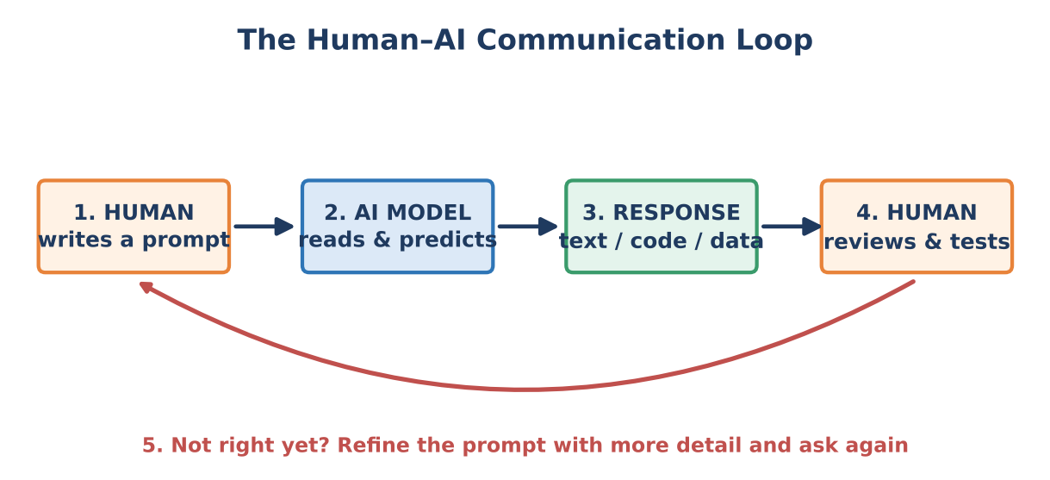
Figure 1: The human–AI communication loop
- The AI sees only what you give it: your current message and the earlier messages in the same conversation (its context). It cannot read your mind or see your screen.
- If the answer is not what you wanted, the usual fix is a better prompt, not a different tool.
- Always review the response. The human stays in charge of the final result.

3. Writing Good Prompts
A prompt is the instruction or question you give to the AI. The quality of the output depends strongly on the quality of the prompt. A good prompt usually answers five questions.
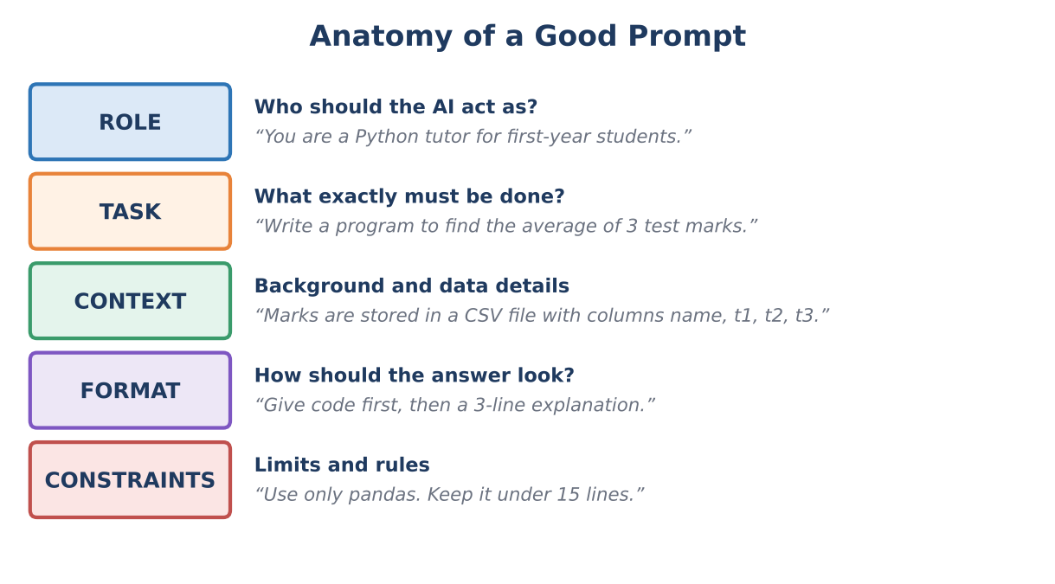
Figure 2: The five parts of a good prompt

3.1 Vague versus specific
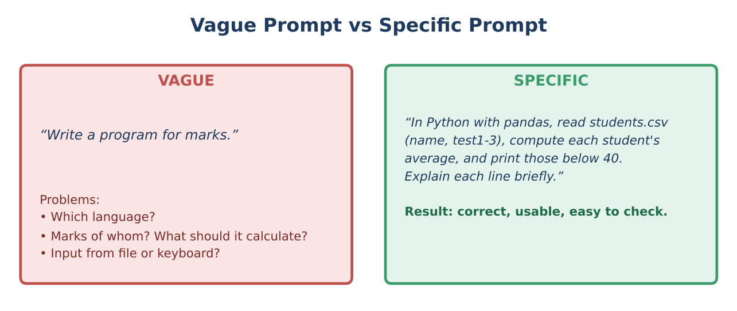
Figure 3: A specific prompt removes guesswork

3.2 Useful prompting techniques
Technique | What to do | Example
Give context | Describe your data, tools and goal. | “My CSV has columns name, attendance, test1–test3.”
Be specific | Say exactly what output you need. | “Print students whose average is below 40.”
Show an example | Give a sample input and the output you expect. | “Input: 35, 40, 38 → Output: 37.7”
Set the format | Ask for code first, a table, or bullet points. | “Give code, then explain in 3 lines.”
Add constraints | Limit tools, length or style. | “Use only pandas; no external libraries.”
Go step by step | Break a big task into small parts. | “First clean the data. Then I will ask for analysis.”
Iterate | Refine using the previous answer. | “Good. Now also show the count of each group.”

3.3 Prompts that help while programming
- Explain: “Explain this code line by line for a second-year student.”
- Debug: “This code gives the error below. Explain the cause and show the fix.” (paste the exact error message)
- Test: “Write 5 test cases for this function, including edge cases.”
- Improve: “Make this code shorter and easier to read without changing the result.”
- Convert: “Rewrite this loop using pandas.”

A complete example prompt
“You are a Python tutor. I have a pandas DataFrame df with columns name, attendance, test1, test2, test3. Write code that (1) adds an average-marks column, (2) labels each student ‘Needs support’ if average < 40 or attendance < 65, and (3) prints the number of students in each label. Use only pandas and add a short comment on each step.”

4. Programming with AI
Programming with AI means using an AI assistant as a partner while you design, write, test and understand programs. The AI speeds up the work, but the programmer still has to understand the problem and check the result.

4.1 Five roles of AI in programming
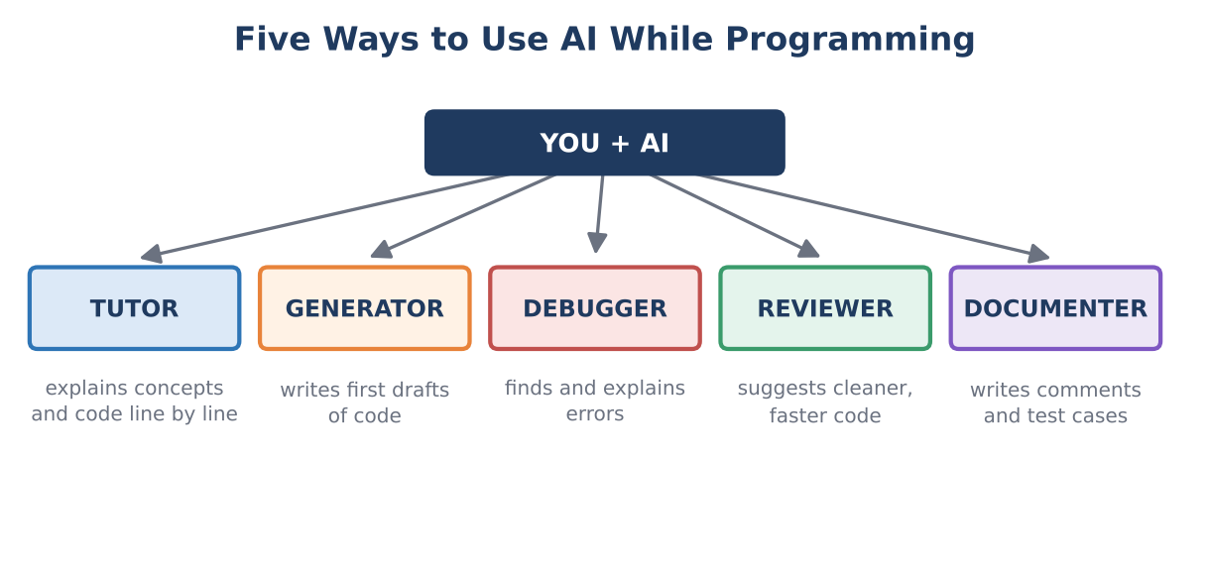
Figure 4: Different ways AI can help a programmer

4.2 A safe workflow
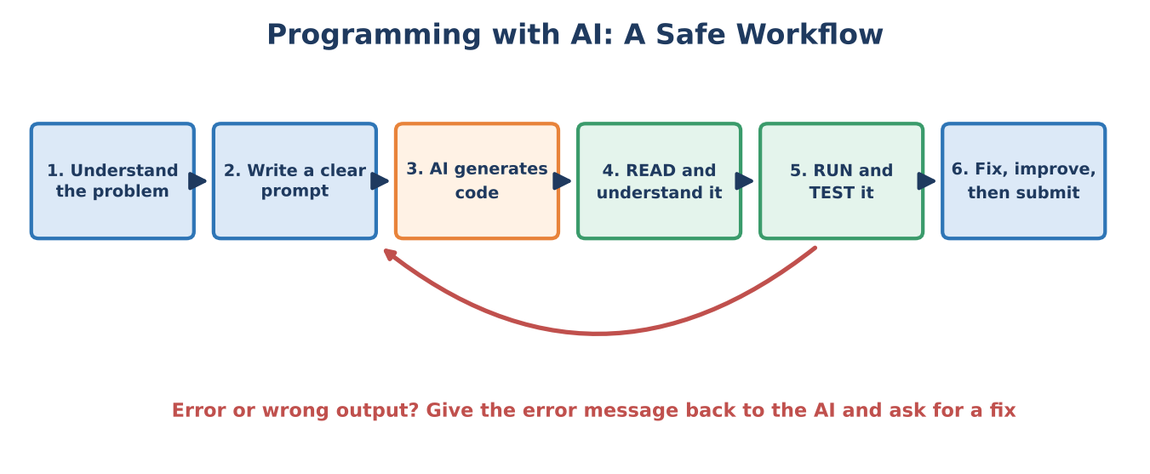
Figure 5: Programming with AI – read and test before you trust
- Understand the problem first. Write in your own words what the input is and what output you need.
- Write a clear prompt using the five parts (role, task, context, format, constraints).
- Let the AI generate a first version of the code.
- Read and understand every line. If you do not understand something, ask the AI to explain it.
- Run and test with small data where you already know the answer.
- Fix and improve. Paste any error message back to the AI and ask for help. Then make the code your own.

4.3 Do and don’t
Do | Don’t
Use AI to learn: ask “why does this work?” | Copy code you do not understand
Test the code on sample data | Assume that code which runs is code that is correct
Give the exact error message when debugging | Paste passwords, API keys or personal data into a prompt
Mention AI help when your college rules require it | Submit AI-written work as entirely your own where this is not allowed

5. From Data to Decisions
A decision is a choice between possible actions. Good decisions are based on evidence, and in a digital world this evidence comes from data. But raw data alone is not enough; it must be processed step by step. This is often explained with the DIKW pyramid: Data, Information, Knowledge and finally a Decision (the wise action).
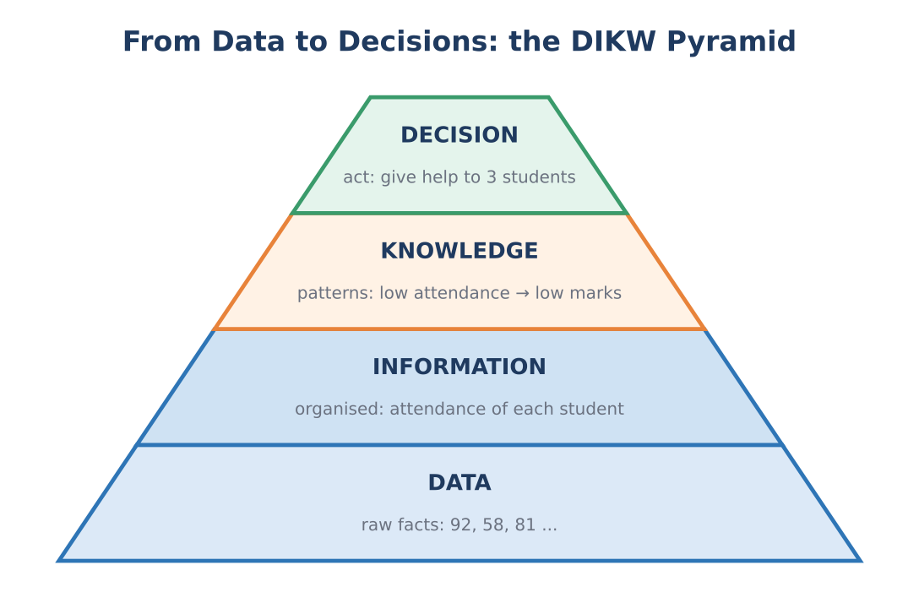
Figure 6: The DIKW pyramid
Level | Meaning | Example
Data | Raw facts and numbers with no meaning yet. | 92, 58, 81, 70 ...
Information | Data that is organised and labelled. | “Attendance of Asha is 92%.”
Knowledge | Patterns and understanding found in the information. | Students with low attendance tend to score low marks.
Decision | A chosen action based on the knowledge. | Arrange extra classes for the three struggling students.

5.1 The data-to-decision pipeline
In programming, the journey from data to decision is a pipeline of steps. Each step can be written as code, and AI can help with each of them.
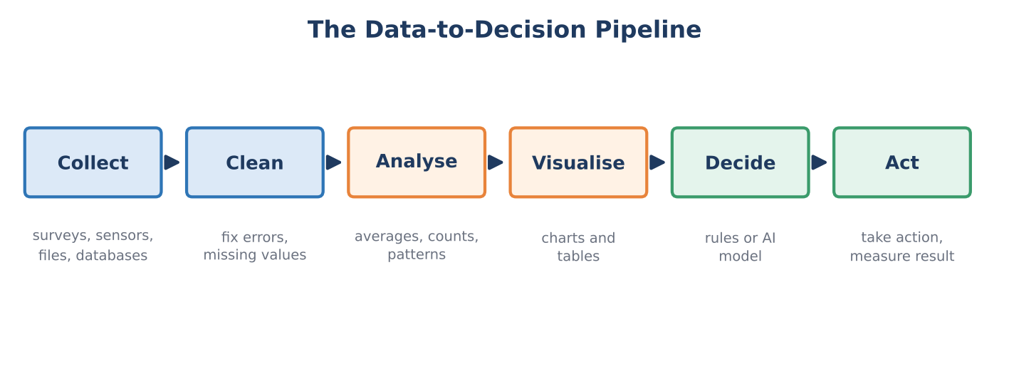
Figure 7: The data-to-decision pipeline
Step | What happens | How AI can help
Collect | Gather data from files, forms, sensors or databases. | Suggest data sources and file-reading code.
Clean | Fix wrong values, fill gaps and remove duplicates. | Write cleaning code and spot odd values.
Analyse | Calculate averages, counts, comparisons and trends. | Suggest and write the calculations.
Visualise | Show results as charts and tables. | Generate plotting code and suggest chart types.
Decide | Apply rules or a trained model to choose an action. | Help design the rules or build a model.
Act | Carry out the decision and check the result. | Draft reports or messages; humans take the action.

6. Case Study: A Student Support Program

6.1 The problem
A class teacher has the attendance and three test marks of ten students. The teacher wants a program that decides which students need extra support, which are on track, and which are excellent. This is a small but complete example of turning data into decisions.

6.2 The data
Name | Attendance % | Test 1 | Test 2 | Test 3
Asha | 92 | 78 | 82 | 85
Bala | 58 | 35 | 40 | 38
Charu | 81 | 60 | 65 | 70
Dev | 70 | 45 | 50 | 48
Esha | 96 | 88 | 91 | 94
Farid | 62 | 30 | 38 | 42
Gita | 88 | 70 | 74 | 77
Hari | 74 | 52 | 58 | 55
Indu | 55 | 28 | 33 | 30
Jai | 90 | 82 | 79 | 88
Table 1: Sample class data (marks out of 100)

6.3 The decision rule
The teacher decides on these rules. Notice that the numbers 40, 65, 75 and 85 are human choices; the program only applies them consistently to every student.
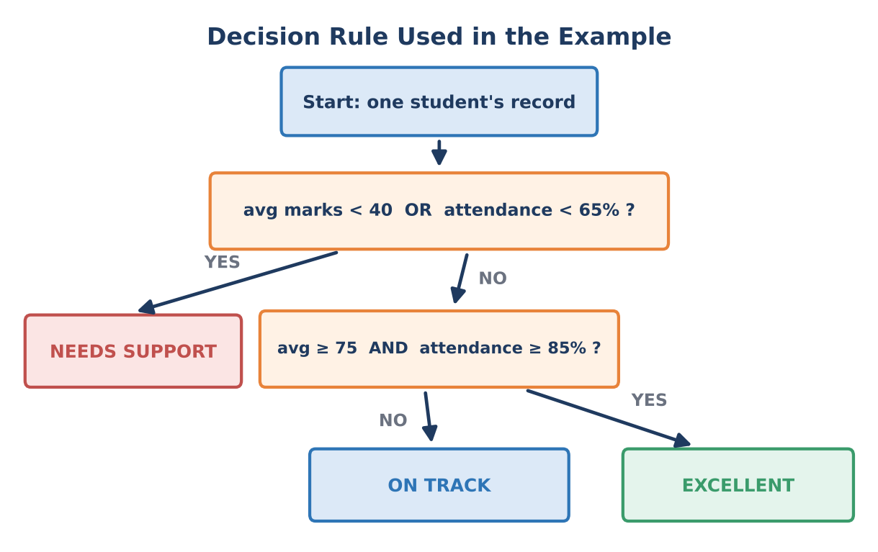
Figure 8: Flowchart of the decision rule

6.4 The program (Python with pandas)
The code below follows the pipeline: it prepares the data, applies the rule and prints a report. A prompt like the example in Section 3.3 can be used to get a first version from an AI assistant. The code was run, and the output shown in the next box is the real output.
Python code
import pandas as pd

# 1. Data (normally read with pd.read_csv("students.csv"))
data = {
"name": ["Asha", "Bala", "Charu", "Dev", "Esha",
"Farid", "Gita", "Hari", "Indu", "Jai"],
"attendance": [92, 58, 81, 70, 96, 62, 88, 74, 55, 90],
"test1": [78, 35, 60, 45, 88, 30, 70, 52, 28, 82],
"test2": [82, 40, 65, 50, 91, 38, 74, 58, 33, 79],
"test3": [85, 38, 70, 48, 94, 42, 77, 55, 30, 88],
}
df = pd.DataFrame(data)

# 2. Prepare: average marks of the three tests
df["avg_marks"] = df[["test1", "test2", "test3"]].mean(axis=1).round(1)

# 3. Decision rule
def decide(row):
if row["avg_marks"] < 40 or row["attendance"] < 65:
return "Needs support"
elif row["avg_marks"] >= 75 and row["attendance"] >= 85:
return "Excellent"
else:
return "On track"

df["decision"] = df.apply(decide, axis=1)

# 4. Report
show = ["name", "attendance", "avg_marks", "decision"]
print(df[show].to_string(index=False))
print()
print(df["decision"].value_counts().to_string())

Output when the program is run
name attendance avg_marks decision
Asha 92 81.7 Excellent
Bala 58 37.7 Needs support
Charu 81 65.0 On track
Dev 70 47.7 On track
Esha 96 91.0 Excellent
Farid 62 36.7 Needs support
Gita 88 73.7 On track
Hari 74 55.0 On track
Indu 55 30.3 Needs support
Jai 90 83.0 Excellent

decision
On track 4
Excellent 3
Needs support 3

6.5 Understanding the code
- pd.DataFrame(data): puts the data into a table with rows (students) and columns (attendance, marks).
- df[[…]].mean(axis=1): calculates the average of the three test columns for every row.
- def decide(row): a function holding the decision rule using if / elif / else.
- df.apply(decide, axis=1): runs the function on every student and stores the result in a new column.
- value_counts(): counts how many students fall in each decision group.

6.6 Visualising the result
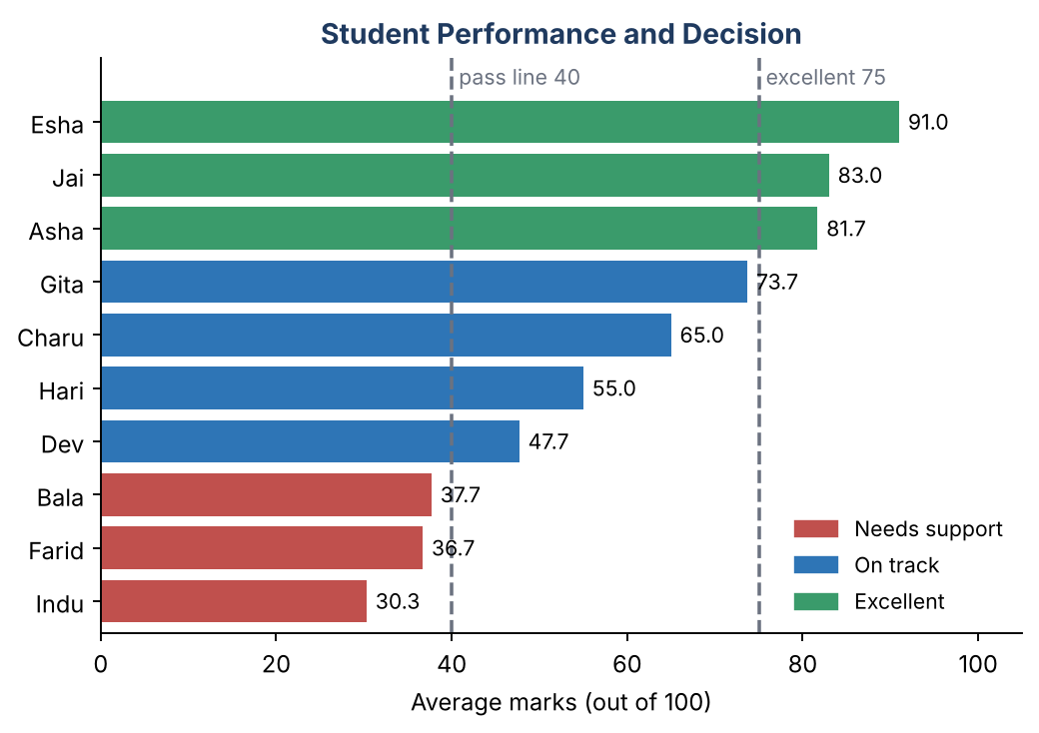
Figure 9: Average marks coloured by decision (dashed lines show the two thresholds)
The chart makes the decision easy to see. Three students (Bala, Farid, Indu) are below the pass line and need support; three (Esha, Jai, Asha) are excellent; four are on track.
Think about it
Gita’s average is 73.7, just below the excellent line of 75, so she is labelled ‘On track’. If the teacher changed the line to 73, she would become ‘Excellent’. This shows that thresholds are human judgements and small changes can change decisions. The program is consistent, but fairness depends on the rule you choose.

6.7 Ways to improve the program
- Read real data from a file using pd.read_csv(“students.csv”).
- Add more factors such as assignment marks, previous-year results or participation.
- Replace hand-written rules with a machine-learning model (for example a decision tree) that learns from past years’ results.
- Show the reasons for each decision, so that a teacher can understand and challenge it.

7. How Do We Make the Decision?

7.1 Three ways to decide
Method | How it works | Good for | Limits
Rule-based | Humans write if-then rules (as in our case study). | Clear policies; easy to explain. | Hard to write rules for complex problems.
Statistical / threshold | Decide using averages, percentages or scores compared with a limit. | Simple monitoring and reports. | The limit is a judgement and may not suit everyone.
Machine learning | A model learns patterns from past data and predicts. | Complex patterns (fraud, medical images, recommendations). | Needs lots of good data; can be hard to explain; can be biased.

7.2 Who makes the final decision?
Even when AI helps, we must choose how much control to give it. This depends on how serious the consequences of a wrong decision are.
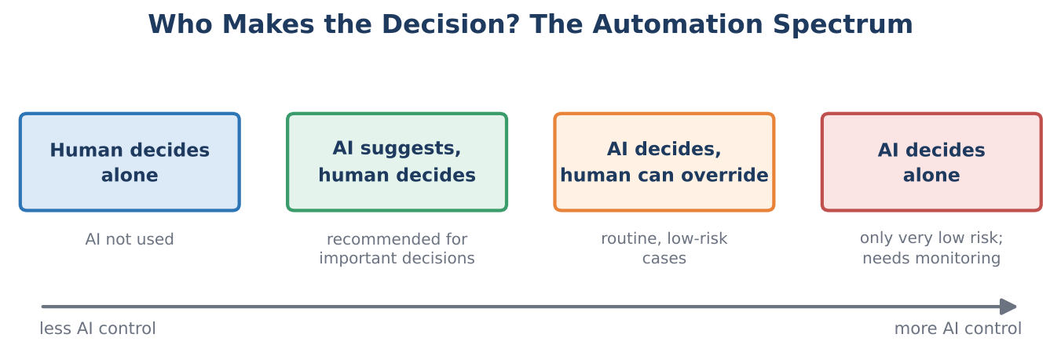
Figure 10: The automation spectrum
- AI suggests, human decides: the best choice for important decisions such as marks, admissions, medical or legal matters.
- AI decides, human can override: acceptable for routine, low-risk tasks such as sorting emails.
- AI decides alone: only for very low-risk tasks, with regular monitoring.
Key idea: human in the loop
AI can process data far faster than a person, but a person understands the context, can question the result and is accountable for the outcome. A good system keeps a human in the loop whenever a decision affects people’s lives or opportunities.

8. Checking AI-Generated Code
AI-written code often looks professional even when it contains mistakes. A programmer must always verify it. Use this checklist.
Check | How to do it
Does it run? | Run the code. If there is an error, give the full message to the AI or search for it.
Is the answer correct? | Test with a small example whose answer you can calculate by hand.
Edge cases | Try empty data, missing values, zero, negative numbers and very large values.
Do I understand it? | Explain each line in your own words. Ask the AI if something is unclear.
Is it safe? | Look for hard-coded passwords, deleted files or unsafe downloads.
Does it fit the rules? | Check that it uses only allowed libraries and meets your assignment instructions.

Worked check using the case study
The program says Asha’s average is 81.7. Verify by hand: (78 + 82 + 85) / 3 = 245 / 3 = 81.67, which rounds to 81.7. ✔
For Bala: (35 + 40 + 38) / 3 = 113 / 3 = 37.67 → 37.7, which is below 40, so ‘Needs support’ is correct. ✔

8.1 Common problems with AI code
- Hallucinated functions: the AI uses a function or library option that does not exist.
- Outdated code: it follows an older version of a library.
- Silent logic errors: the code runs but gives wrong results, for example using > where >= is needed.
- Missing edge cases: it works for the sample but fails for unusual data.
- Over-complicated solutions: more code than the problem needs.

9. Using AI Responsibly
Issue | What to remember
Privacy | Do not paste personal or confidential data (names, phone numbers, marks of real people, medical records) into a public AI tool unless it is allowed. Use sample or anonymised data.
Security | Never share passwords, API keys or private files in a prompt.
Bias and fairness | Data and AI models can carry unfair patterns. Check whether decisions treat different groups fairly.
Accountability | The person who uses the AI result is responsible for it. “The AI said so” is not a valid excuse.
Academic honesty | Follow your college’s rules about AI use. Learn from AI; do not let it do the thinking for you.
Transparency | Be ready to explain how a decision was reached and to acknowledge where AI helped.
Over-reliance | Keep practising your own coding and reasoning skills so that you can detect AI mistakes.

10. Summary – Key Points to Remember
Quick revision
• Communicating with AI is a loop: prompt → response → review → refine.
• A good prompt has a role, task, context, format and constraints.
• AI can act as tutor, code generator, debugger, reviewer and documenter, but you must read and test its code.
• Data → Information → Knowledge → Decision (DIKW) describes how raw facts lead to action.
• The pipeline: collect, clean, analyse, visualise, decide, act.
• Decisions can be rule-based, threshold-based or machine-learning based. Thresholds are human judgements.
• Keep a human in the loop for decisions that affect people.
• Verify AI output with hand calculations, edge cases and understanding.
• Protect privacy and security, watch for bias, and stay accountable.

11. Practice Questions

A. Short answer (2 marks)
- What is a prompt? Name the five parts of a good prompt.
- What is a hallucination in AI?
- Differentiate between data and information with an example.
- What is meant by “human in the loop”?
- Why should AI-generated code be tested before use?
- Name three steps of the data-to-decision pipeline.

B. Descriptive (5 / 10 marks)
- Explain the human–AI communication loop with a diagram.
- Compare a vague prompt and a specific prompt with an example. Why does the specific prompt work better?
- Explain the safe workflow for programming with AI.
- Explain the DIKW pyramid with an example from your college.
- Compare rule-based and machine-learning decision making.
- Discuss the ethical issues in using AI to make decisions about people.

C. Practical / lab tasks
- Write a prompt asking an AI to read a CSV of your own class timetable and count the classes per day. Run the code and check the answer by hand.
- Change the rules in the case study (for example the ‘excellent’ line to 70). Predict which students change group, then run the program to check your prediction.
- Add a fourth group, ‘Needs attention’, for students with attendance below 75 but marks above 40. Ask an AI for help, then explain every line of the code you finally use.
- Ask an AI to explain the case-study code. Find one place where the explanation could be wrong or unclear, and describe how you verified it.

D. Think and discuss
- Should an AI alone decide which students get a scholarship? Give reasons for and against, and suggest a fair process.

12. Glossary
Term | Meaning
AI assistant | A program (often built on an LLM) that answers questions and helps with tasks in natural language.
Constraint | A limit or rule given in a prompt, such as the library to use or the length of the answer.
Context | The earlier messages and details the AI can use when replying.
DataFrame | A table of data in Python’s pandas library.
DIKW | Data, Information, Knowledge, Wisdom (decision): a model of how data becomes action.
Hallucination | A confident but false or invented answer from an AI.
Human in the loop | A design where a person reviews or approves the AI’s output or decision.
LLM | Large Language Model: an AI model trained on large amounts of text and code.
Pipeline | A series of steps that data passes through, from collection to action.
Prompt | The instruction or question given to an AI.
Threshold | A limit value used for deciding, such as a pass mark of 40.
Token | A small piece of text (part of a word) that a language model reads and writes.

— End of Notes —

